Title: Is Earlier Cranioplasty Associated With Greater Neurologic Improvement? A Systematic Review and Meta-Analysis
Authors: James Malcolm, Ph.D.; Rima Sestokas Rindler, M.D.; Jason Chu, M.D.; Falgun Chokshi, M.D.; Gustavo Pradilla M.D.; Faiz Ahmad, M.D., M.Ch.

Introduction:
Cranioplasty following decompressive craniectomy often improves patient neurologic status. It is unknown whether timing of cranioplasty affects the rate of neurologic improvement or ultimate outcome. This study reports a systematic review and meta-analysis comparing neurological outcome for patients undergoing early versus late cranioplasty after decompressive craniectomy.

Methods
A systematic literature search adherent to PRISMA guidelines was performed using PubMed and Scopus. Articles reporting quantitative neurologic outcomes as a function of cranioplasty timing following decompressive craniectomy were included. Pre- and post-procedure neurologic assessments (mean, standard deviation) for cranioplasty performed within (early) and beyond (late) 3 months were abstracted. Standard mean difference (SMD) between pre- and post-cranioplasty scores were analyzed for each outcome assessment.

Results:
Eight of 311 articles met inclusion criteria (total 528 patients; 238 early vs. 290 late). Overall, only Karnofsky Performance Status was significantly improved for early vs late cranioplasty (n=2; SMD 0.91, CI= 0.27-1.55, p=0.006). There was a trend toward greater magnitude of neurologic improvement for Barthel Index (n=4; SMD 2.41, CI -0.83-5.65, p=0.15), and significantly greater magnitude of improvement for Karnofsky Performance Status (n=1; SMD 7.17, CI 5.91-8.44, p<0.001).

Conclusion:
Early cranioplasty may be associated with better neurologic outcome and greater magnitude of neurologic improvement compared with late cranioplasty. Prospective studies utilizing uniform outcome assessments are required to confirm these findings.

Figure 1: PRISMA Flow Diagram
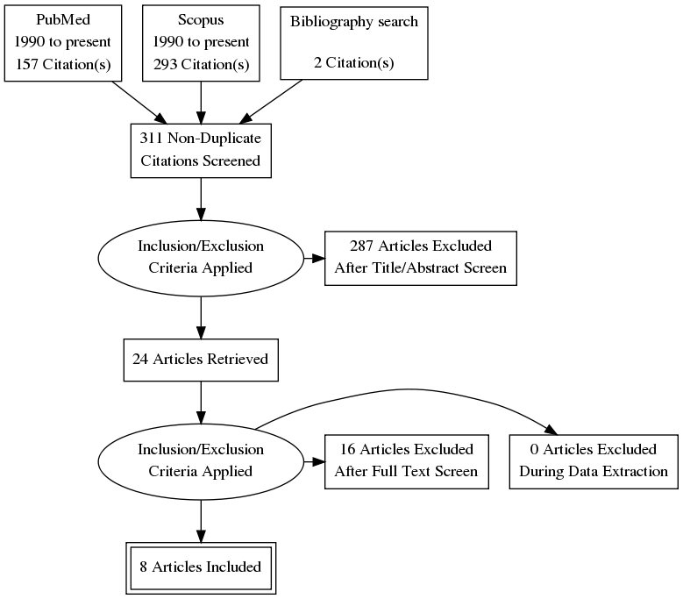

Figure 2: Pre-cranioplasty scores for BI, KPS, and FIM with separate subgroup analysis due to patient overlap.
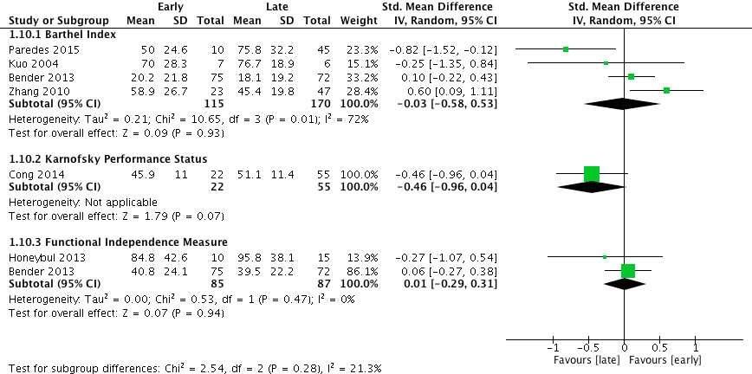

Figure 3: Post-cranioplasty scores for BI, KPS, FIM, and GOS with separate subgroup analysis due to patient overlap.
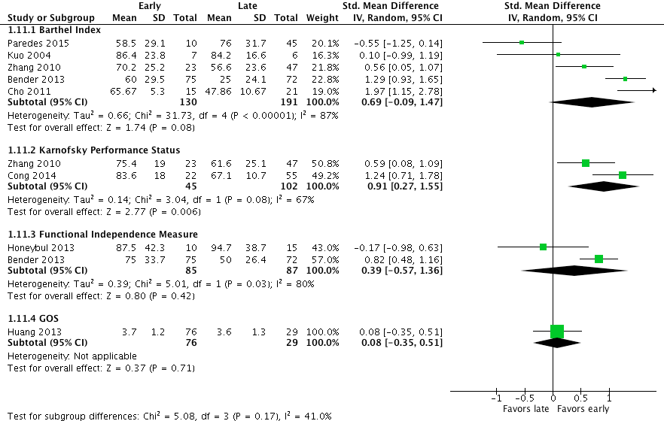

Figure 4: Difference between pre-cranioplasty and post-cranioplasty for BI and KPS with pooled analysis.
