Title: Are Complications Following Cranioplasty Related To Its Timing After The Decompressive Surgery? A Systematic Review and Meta-Analysis
Authors: James Malcolm, Ph.D.; Rima Sestokas Rindler, M.D.; Jason Chu, M.D.; Jonathan Grossberg, M.D.; Gustavo Pradilla M.D.; Faiz Ahmad, M.D., M.Ch.

Introduction:
Cranioplasty following decompressive craniectomy carries known complication risks; however, it is unknown whether the timing of cranioplasty affects the incidence of specific complications. This study reports a meta-analysis of complication rates between patients undergoing early versus late cranioplasty after decompressive craniectomy.

Methods:
A systematic literature search adherent to PRISMA guidelines was performed using PubMed and Scopus. Articles reporting complications related to timing of cranioplasty following decompressive craniectomy were included. Odds ratios [OR, 95% Confidence Interval (CI)] of overall complications, infection, resorption, reoperation, extra-axial fluid collection, seizure, and hydrocephalus were pooled and compared for cranioplasty performed within (early) and beyond (late) 3 months.

Results:
Twenty-three of 319 articles met inclusion criteria (total 2713 patients; 1292 early vs. 1421 late). Early cranioplasty is associated with an increased rate of hydrocephalus (n=4, OR 2.34, CI 1.09-5.03, p=0.03), often requiring a ventriculoperitoneal shunt. There was no significant difference in odds of overall complications (n=22, OR 1.14, CI 0.81-1.60), infection (n=16, OR 1.19, CI 0.81-1.75), resorption (n=2, OR 0.89, CI 0.44-1.81), reoperation (n=8, OR 0.77, CI 0.50-1.18), extra-axial fluid collections (n=9, OR 0.73, CI 0.45-1.17), or seizure (n=3, OR 1.03, 0.48-2.22) in early versus late cranioplasty.

Conclusion:
Early cranioplasty after decompressive craniectomy is associated with an increased rate of hydrocephalus compared with late cranioplasty. There was no significant difference in overall complications. Prospective studies should determine optimal cranioplasty timing for specific patient populations.

Figure 1: PRISMA Flow Diagram
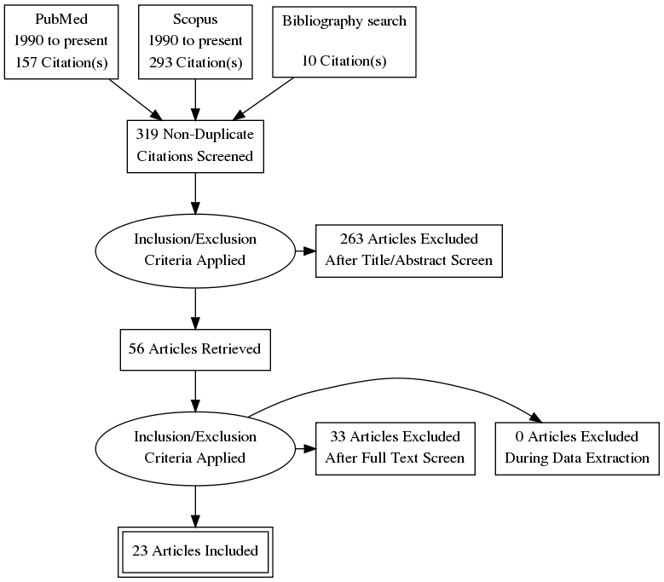

Figure: Overall Complications
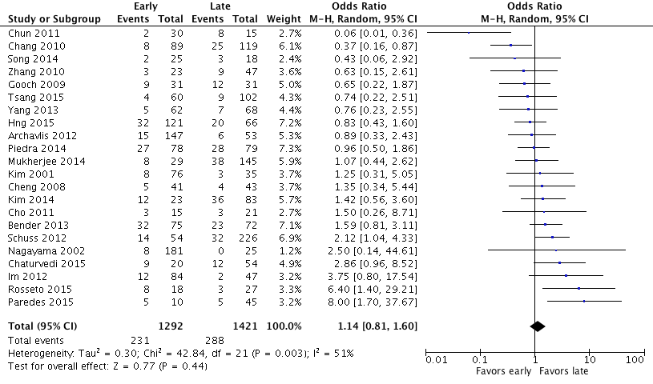

Figure: Infection
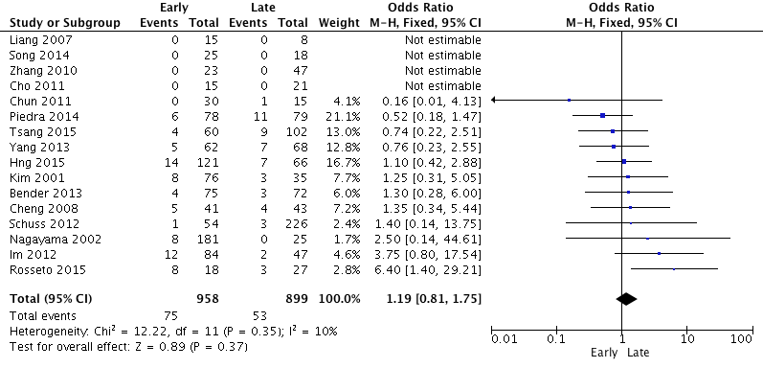

Figure: Resorption
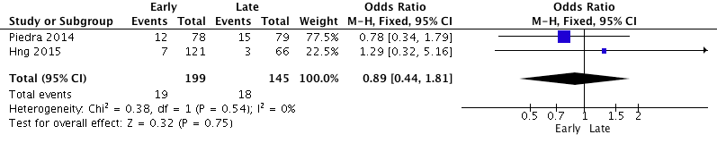

Figure: Reoperation
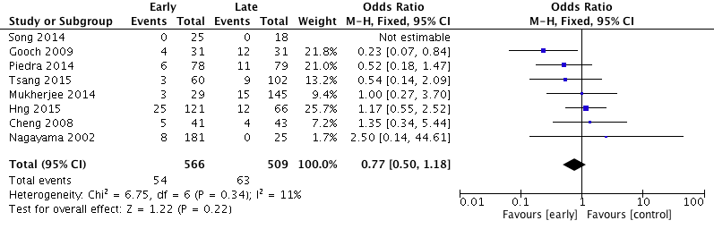

Figure: Extra-Axial Fluid Collection
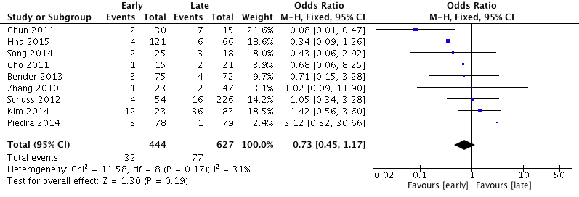

Figure: Seizure
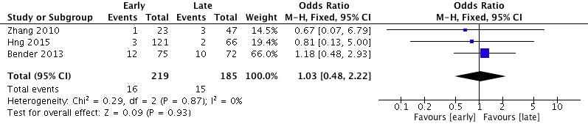

Figure: Hydrocephalus
